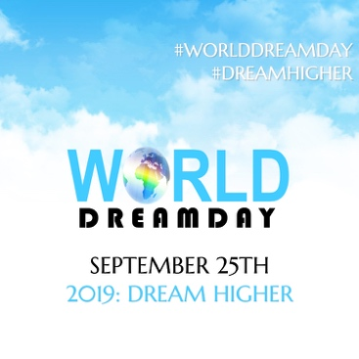
Celebrating Seven Years Of Advancing Dreams And Making A Difference!
World Dream Day celebrates its 7th year through dedicating this day towards the exploration of elevated dreams and elevated action.
Held September 25th, World Dream Day is the ONLY global participatory day held with the express purpose of encouraging and activating ideas, goals, and dreams. Every year, through live and online events, World Dream Day inspires, empowers, and ignites individuals, families, businesses, and communities all over the world to rise up, declare new possibilities and take a stand for what they truly desire and deserve - for themselves, and our world.

World Dream Day 2019 will be a day of Inspiration, Reflection, and Celebration.
***Anyone can participate in World Dream Day from anywhere in the world.***
***GET INVOLVED. GIVE YOUR SUPPORT. START SPREADING THE WORD***
Participate by engaging in individual reflection, dynamic conversations and expressive observances: declare your dream via social media, create art, host DreamDinners and spoken word performances, create a public DreamDance, engage in dream-based conversations, host a community gathering, create vibrant public demonstrations, and anything else we haven’t mentioned.
- Post on Social Media! #worlddreamday #DreamItForward
- Download a Dream Declaration HERE.
- Like our FB page HERE [View our global event on our FB page]
- BE VOCAL. USE SOCIAL MEDIA ICONS OR CREATE YOUR OWN!
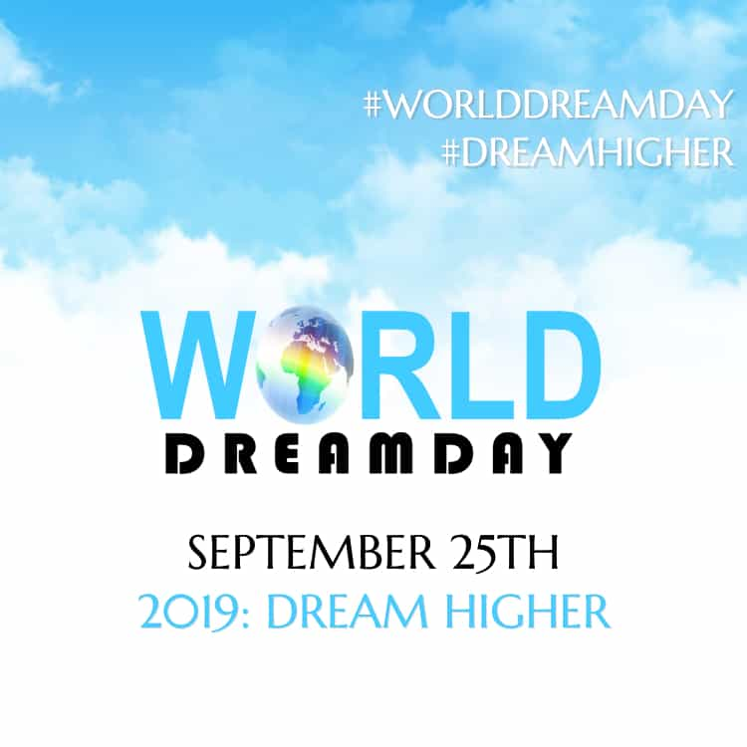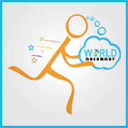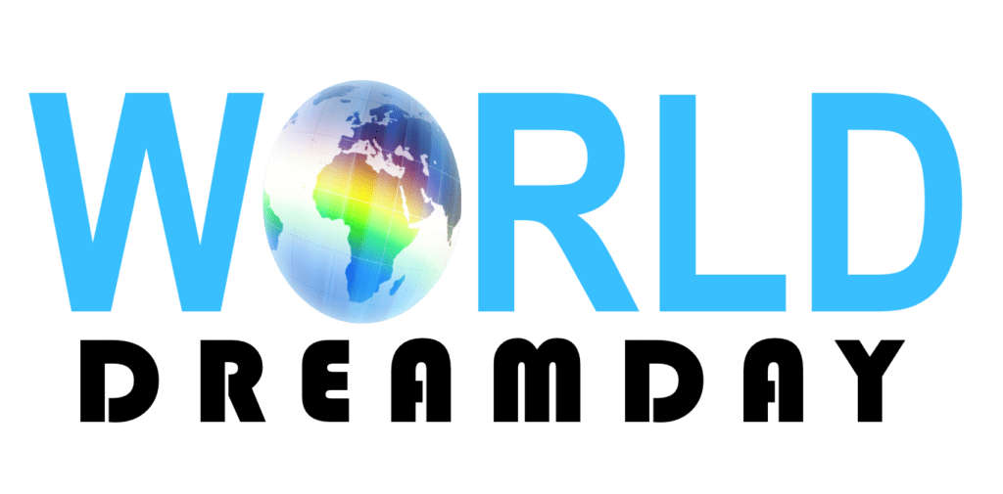

2019 THEME: Dream Higher
World Dream Day 2019 will be a day of celebration and reflection. We invite you to: Explore how to elevate your vision of the future. We invite you to: Elevate your vision of the future of our planet. We invite you: Explore ways of co-creating a better world through elevated action.
All around the world, we sense that now is the time to engage in meaningful action.
We have come to a "choice point" along the journey of human existence. Many changemakers are signaling the importance of action on behalf of planet earth.
It is time for us to take time to reflect on how to re-orient ourselves and rearchitect our personal and collective reality towards the higher dream of a healthy planet and a healthy society.
Due to the many distractions that have become a part of modern life, we have begun to only look down at our screens, and no longer up to the sky.
This year, we invite you to return to setting your vision towards the higher ideas, goals, and dreams that will help elevate yourself AND humanity.

When we #DreamHigher, we begin to realize that it is through an elevated mindset and elevated action that we can achieve elevated results!
A new world is already on its way. However, we must #DreamHigher today!
www.worlddreamday.org | globaldreamsrising@gmail.com
Facebook | Twitter | Instagram: @dayfordreamers
#worlddreamday #DreamHigher

World Dream Day was founded in 2012 to help inspire and heal humanity by Ozioma, a visionary, WATCH THE TEDx TALK.

