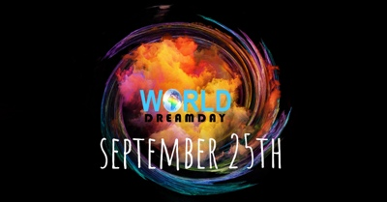

Celebrating Six Years of Advancing Dreams And Making A Difference!

Held September 25th, World Dream Day is the ONLY global participatory day held with the express purpose of encouraging and activating ideas, goals, and dreams. Every year, through live and online events, World Dream Day inspires, empowers, and ignites individuals, families, businesses, and communities all over the world to rise up, declare new possibilities and take a stand for what they truly desire and deserve - for themselves, and our world.

World Dream Day 2018 will be a day of Inspiration, activation, and celebration.
We invite you to: COMMUNICATE-CREATE-CELEBRATE -CONTRIBUTE

***Anyone can participate in World Dream Day from anywhere in the world.***
• Post on Social Media! #worlddreamday #DreamItForward
• Download a Dream Declaration HERE.
• Like our FB page HERE
• Check Going to our global event HERE.
• GET LOUD. BE VOCAL. INVITE YOUR ENTIRE COMMUNITY! HERE

2018 THEME: Dream It Forward
The world of tomorrow is built on the choices we make today. Whether it is the decision to decrease our use of plastic in honor of the dream of healing planet earth, or the decision to stand in solidarity against the energy of divisiveness in service of the dream of one humanity, what we do today makes a difference towards creating the world of tomorrow. It all starts with the ideas, goals, and dreams we hold and what we choose to do to move them forward.

All around the world, people waking up to the reality that we individually and collectively must join forces and take action to awaken a higher dream for humanity.
A new world is already on its way. However, we must #DreamItForward today!

***GET INVOLVED. GIVE YOUR SUPPORT. START SPREADING THE WORD***
Participate by engaging in individual reflection, dynamic conversations and expressive observances: declare your dream via social media, create art, host DreamDinners and spoken word performances, create a public DreamDance, engage in dream-based conversations, host a community gathering, create vibrant public demonstrations, and anything else we haven’t mentioned.

www.worlddreamday.org | globaldreamsrising@gmail.com

Facebook | Twitter | Instagram: @dayfordreamers

#worlddreamday #DreamItForward

World Dream Day was founded in 2012 to help inspire and heal humanity by Ozioma, a visionary.

